EXPERIMENT-11
Aim: Introduction to SQLite database. Set up an SQLite database in your android application. Create a table and perform basic CRUD operations.
Theory:
- What is SQLite?
SQLite is a lightweight database built into Android.
- No internet needed
- Stores data locally (inside the app)
- Used for apps like contacts, notes, etc.

- Create New Android Project
1. Open Android Studio
2. Click New Project
3. Choose Empty Views Activity
4. Name: SQLiteStudentApp
5. Language: Java
6. Click Finish

3. Create Database Helper Class
Right-click → New → Java Class → DatabaseHelper
Explanation:
- SQLiteOpenHelper → Helps create/manage database
- onCreate() → Runs first time → creates table
- onUpgrade() → Updates database when version changes

- Add CRUD Methods
Add below methods inside DatabaseHelper class.
- Insert Data (Create)
Explanation:
- ContentValues → stores data in key-value form
- insert() → inserts row into table
- View Data (Read)
Explanation:
- Cursor → used to read data row by row
- rawQuery() → executes SQL query
- Update Data
This operation modifies the existing data present or stored in tables.
- Delete Data
This operation deletes existing record(s) from a table.

- Design UI (activity_main.xml) which consists of code of all widgets present inside app.

- MainActivity Code is responsible for performing all CRUD operations.

Code:
DatabaseHelper.java
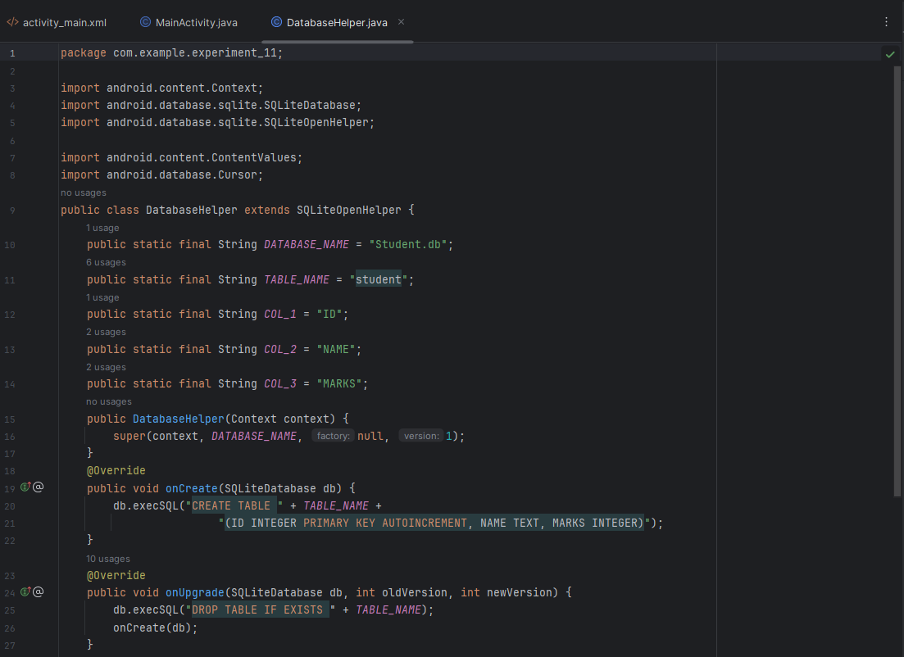
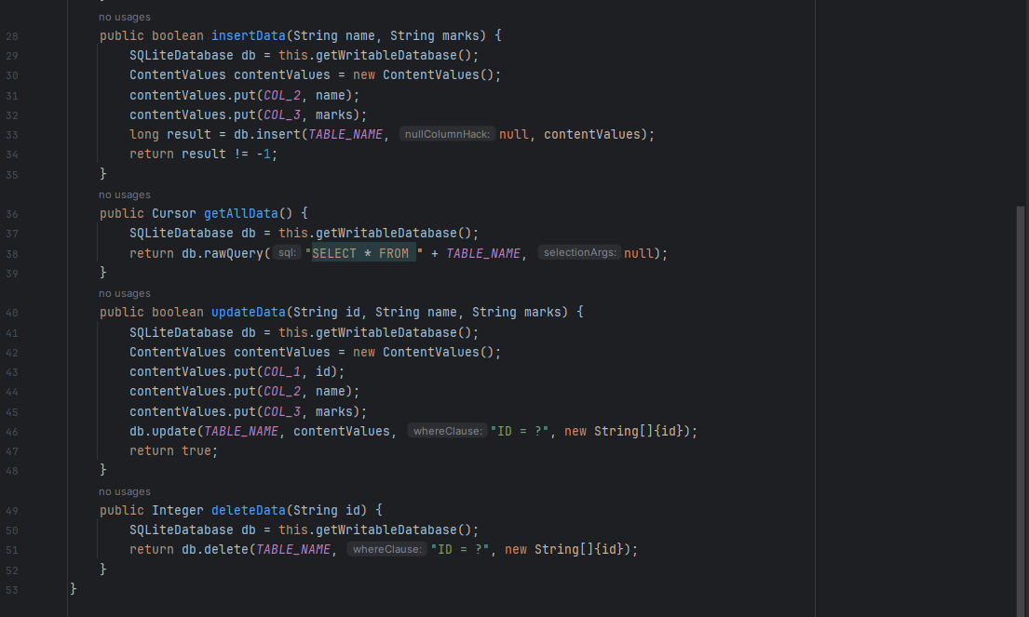

activity_main.xml
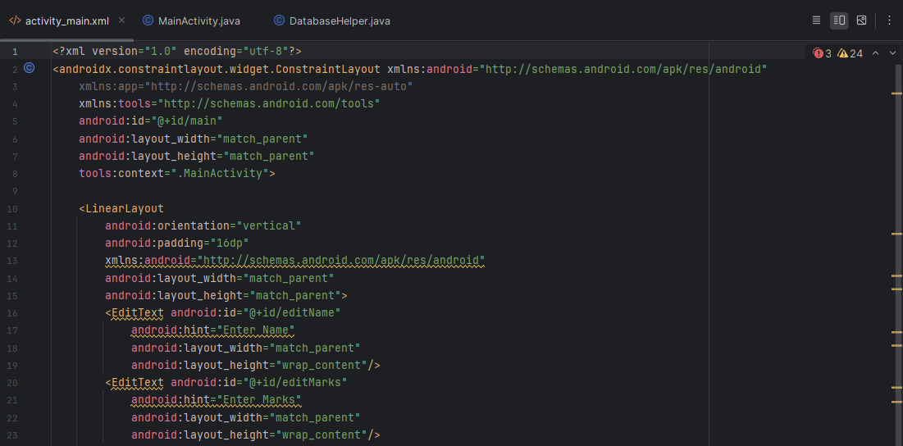
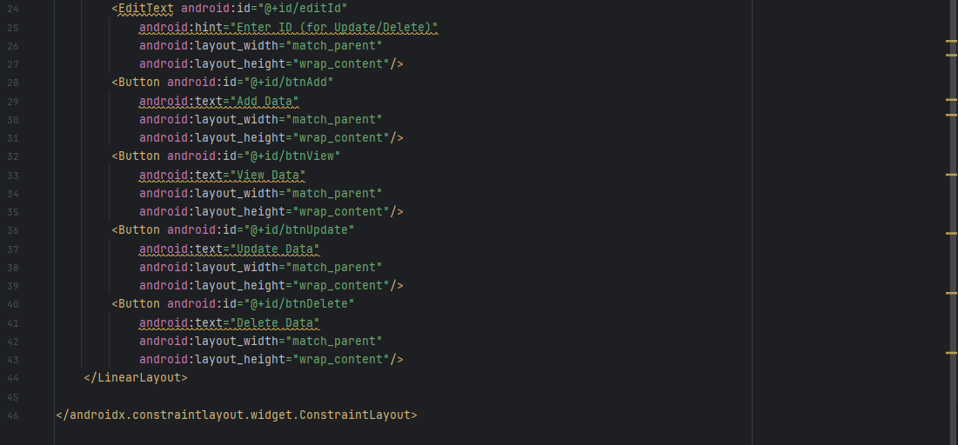

MainActivity.java
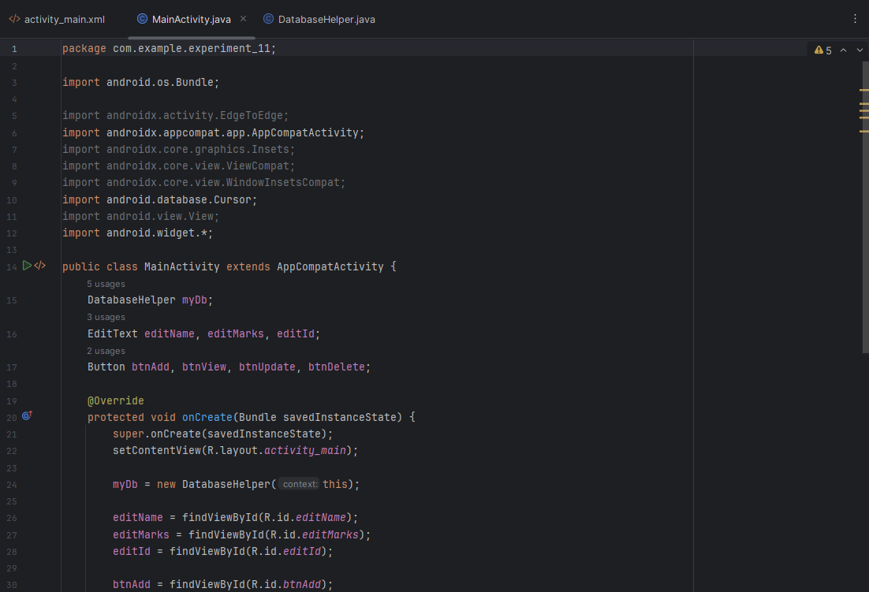
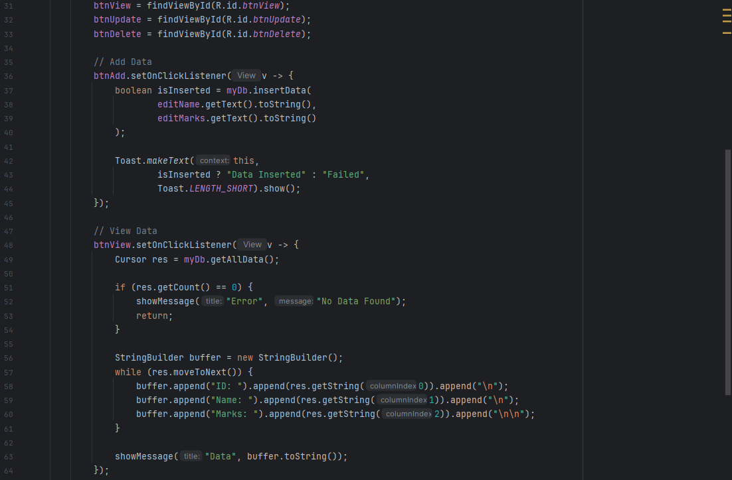
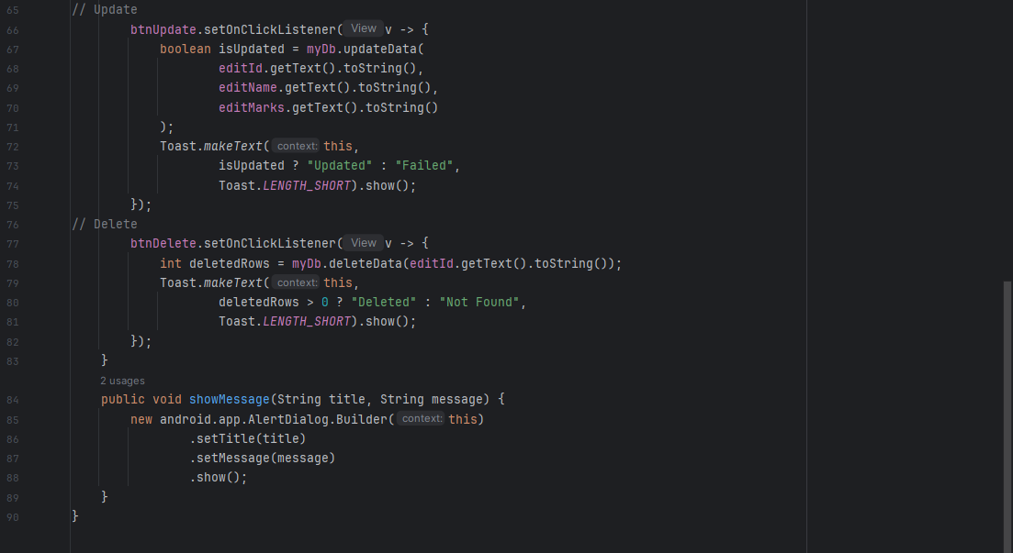

Output:
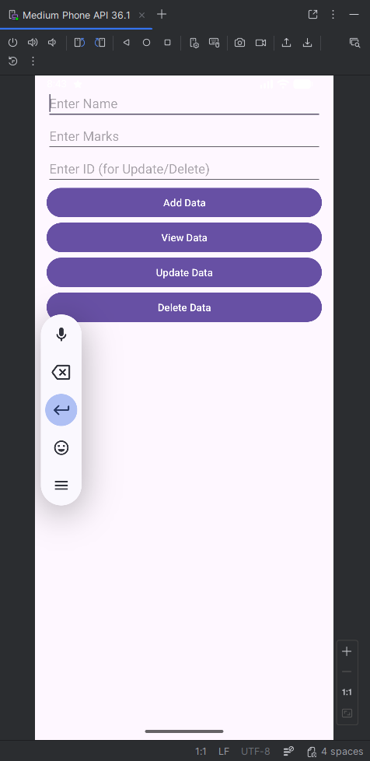

- Insert Operation
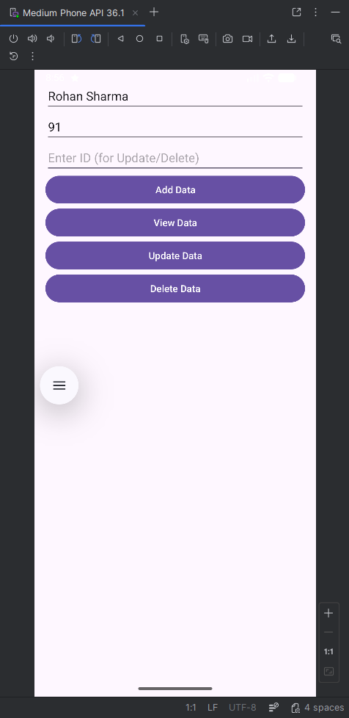 | 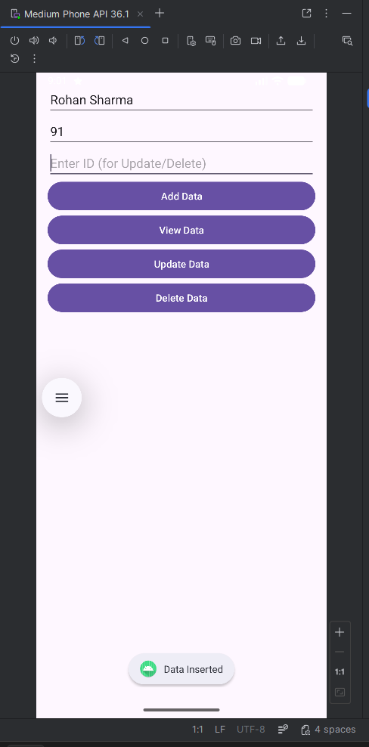

- Read (or View) Operation
 | 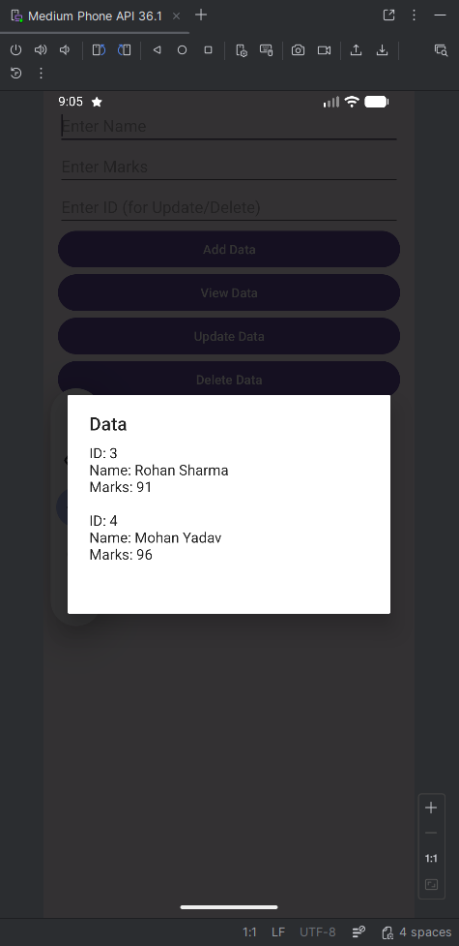

- Update Operation
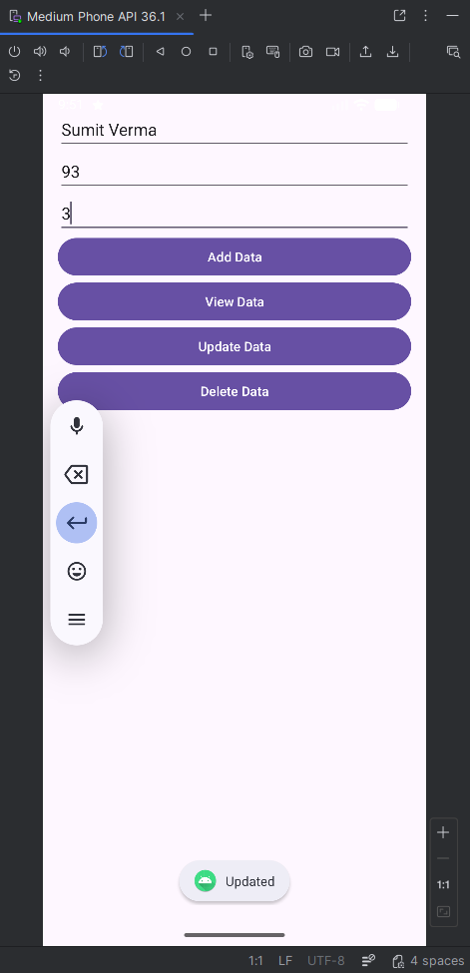 | 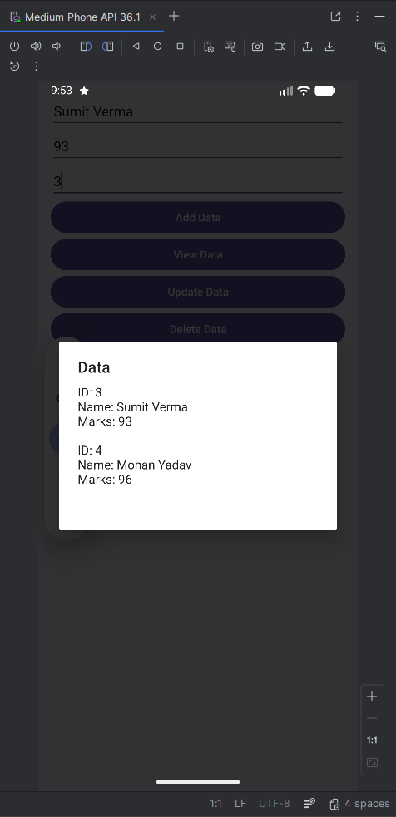

- Delete Operation
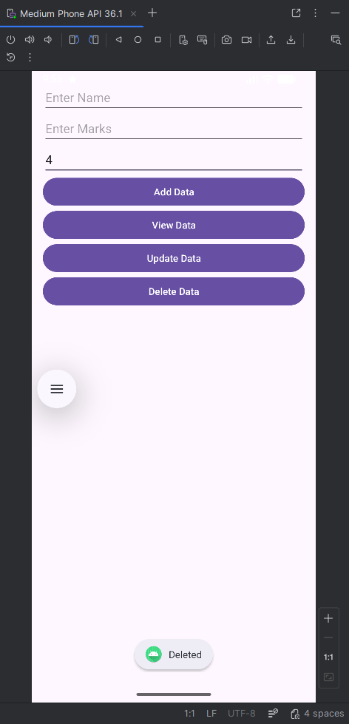 | 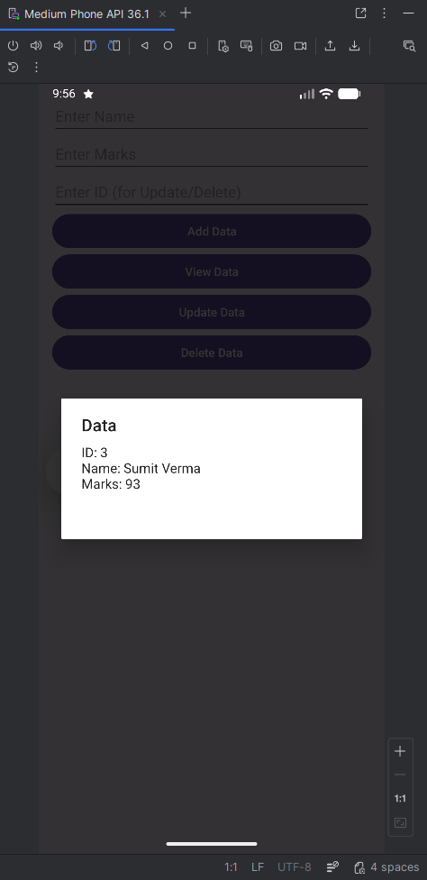

Conclusion:
This experiment demonstrated how to integrate and use an SQLite database in an Android application for local data storage. It provided hands-on experience in creating tables and performing basic CRUD operations such as insert, update, delete, and retrieve. Overall, it strengthened understanding of efficient data management within Android apps.

